# Adding a new team to the main.php file

1). Create a new function between the “<script>” tags change the team number and “myPopup” number for example

here is team 1 and team twos function, notice how the functions and “myPopup” number changes each time.

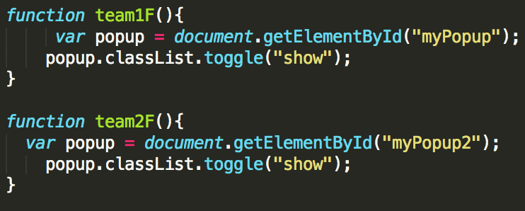

2).Now add the actual image that will be displayed.

Make sure it is in the “centre” div tag. Notice again how we must change the team number with each image. Don’t mind the greyed/commented out text that are in “<!-- -->” tags.

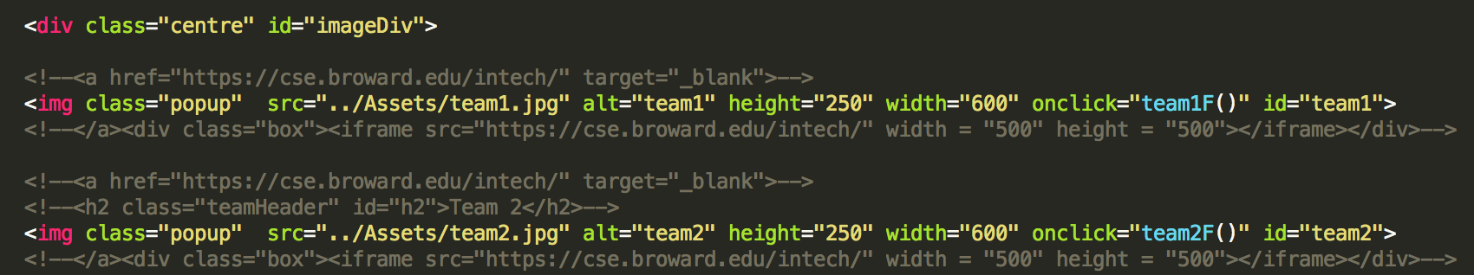

the image “src=” must be an image that is saved in the asset folder with that name.

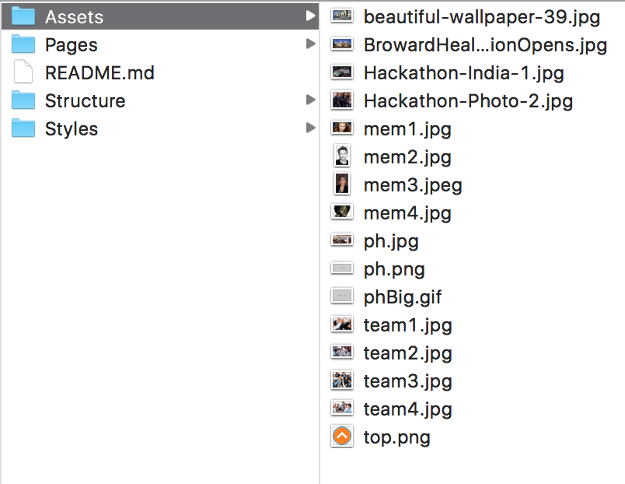

3).Now its time to add a popup for the team page We Will make the page in the next step. Like before we just need to copy a div and make it conform to the team we’d like it to reflect.

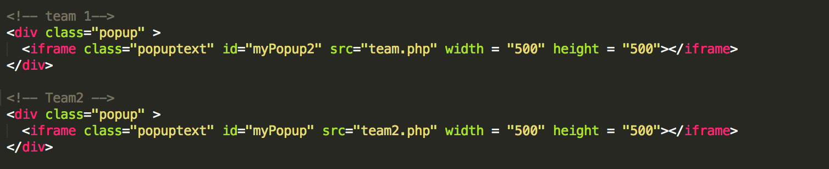

# Adding the actual teams page

What were going to do is copy the whole “team1.php” page and then fill it with contents of the desired team.

Here are the things we’ll need to change

1). Background image

Make sure when you save the image it is in the asset folder with the accurate team name.

The file does not have to be a “.jpg” but make sure the code matches the file type.

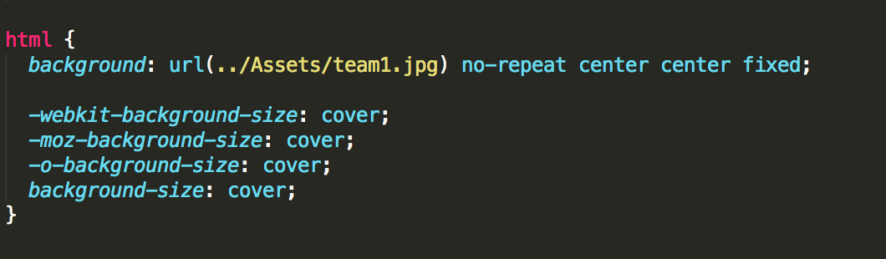

adding members

here like before make sure that the pictures match the one you saved> It may be a good idea to name the pictures like this when when saving them for organizational purposes. “team#Member#.fileType”

remember to update their emails and names in the place holders.

